1)3)

INPUTS OUTPUTS

|  |  |  |  |  |  |  |  |  |  |  |  |  |  |
| --- | --- | --- | --- | --- | --- | --- | --- | --- | --- | --- | --- | --- | --- |
| EI | 0 | 1 | 2 | 3 | 4 | 5 | 6 | 7 | A2 | A1 | A0 | GS | EO |
| 1 | x | x | x | x | x | x | x | x | 1 | 1 | 1 | 1 | 1 |
| 0 | 1 | 1 | 1 | 1 | 1 | 1 | 1 | 1 | 1 | 1 | 1 | 1 | 0 |
| 0 | x | x | x | x | x | x | x | 0 | 0 | 0 | 0 | 0 | 1 |
| 0 | x | x | x | x | x | x | 0 | 1 | 0 | 0 | 1 | 0 | 1 |
| 0 | x | x | x | x | x | 0 | 1 | 1 | 0 | 1 | 0 | 0 | 1 |
| 0 | x | x | x | x | 0 | 1 | 1 | 1 | 0 | 1 | 1 | 0 | 1 |
| 0 | x | x | x | 0 | 1 | 1 | 1 | 1 | 1 | 0 | 0 | 0 | 1 |
| 0 | x | x | 0 | 1 | 1 | 1 | 1 | 1 | 1 | 0 | 1 | 0 | 1 |
| 0 | x | 0 | 1 | 1 | 1 | 1 | 1 | 1 | 1 | 1 | 0 | 0 | 1 |
| 0 | 0 | 1 | 1 | 1 | 1 | 1 | 1 | 1 | 1 | 1 | 1 | 0 | 1 |

2)2)

Function of f(a):

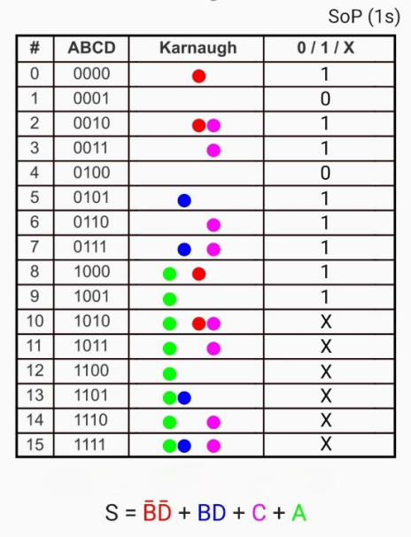 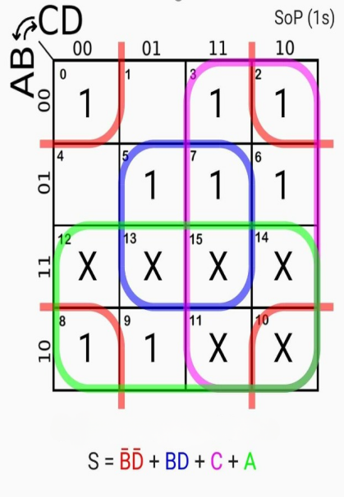

CIRCUIT:

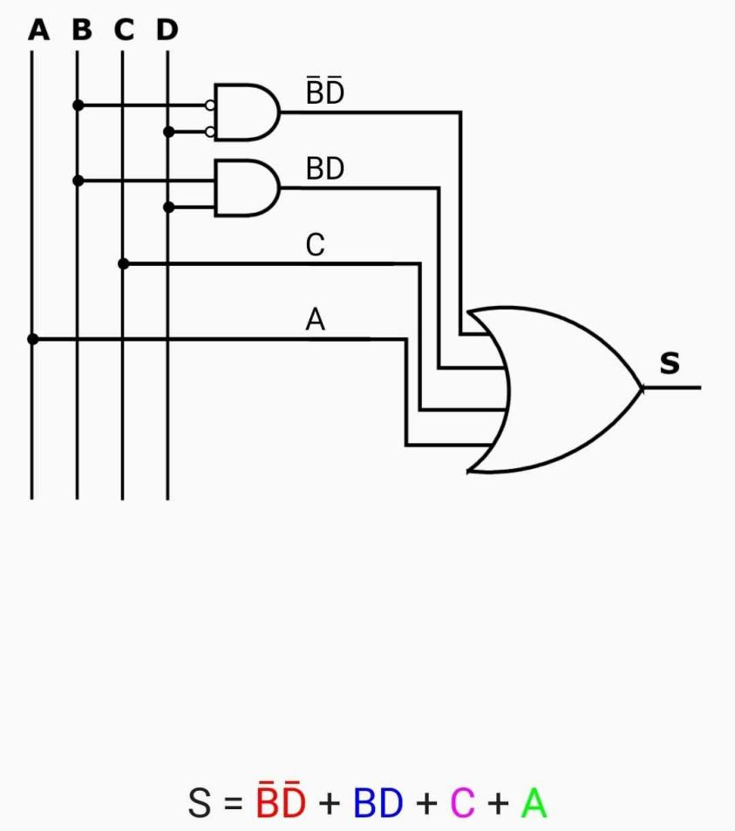

FUNCTION OF F(b):

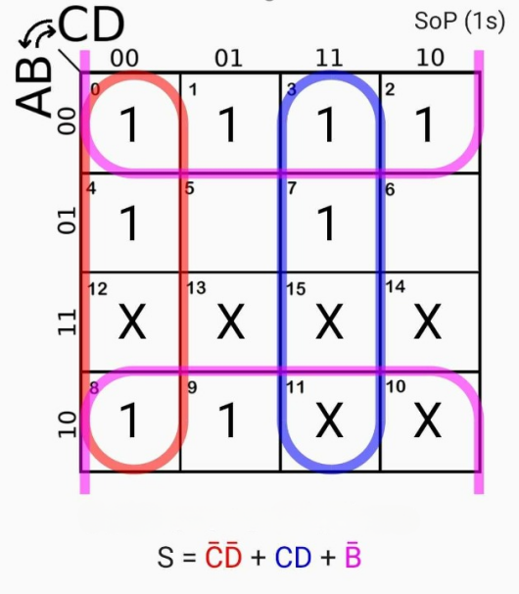 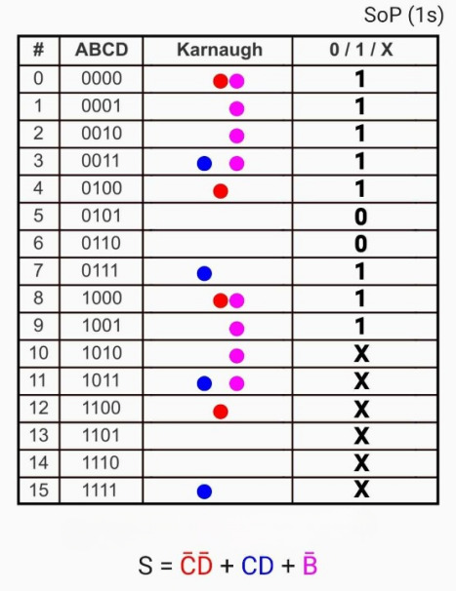

CIRCUIT:

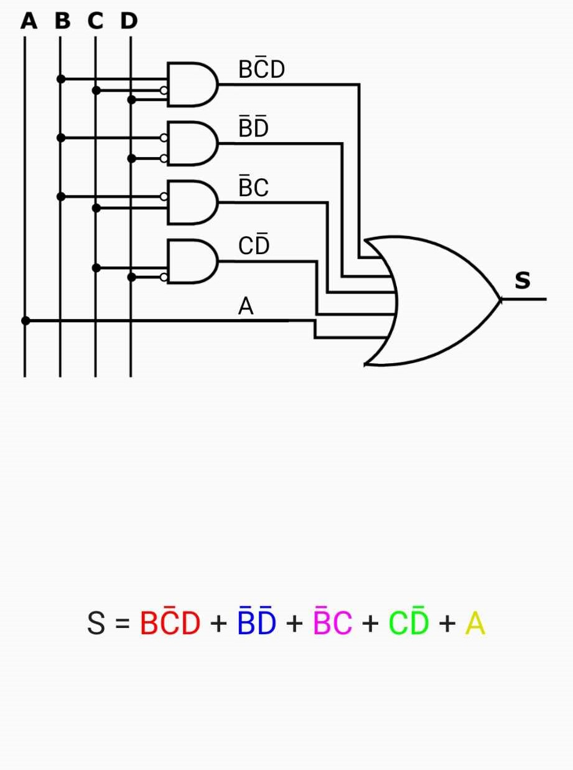

FUNCTION OF F(c):

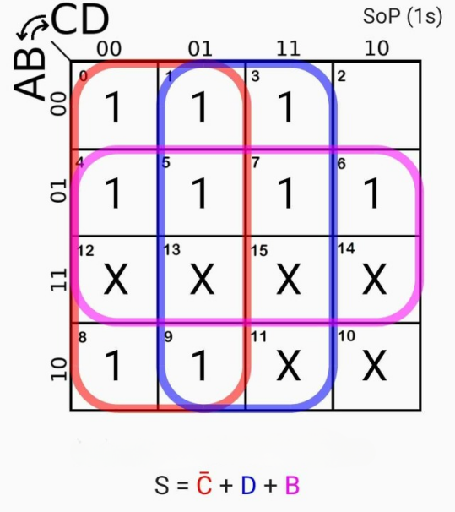 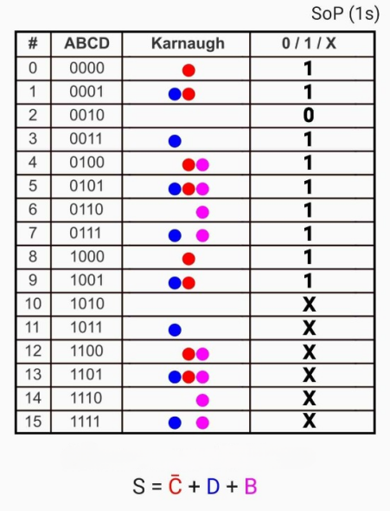

CIRCUIT:

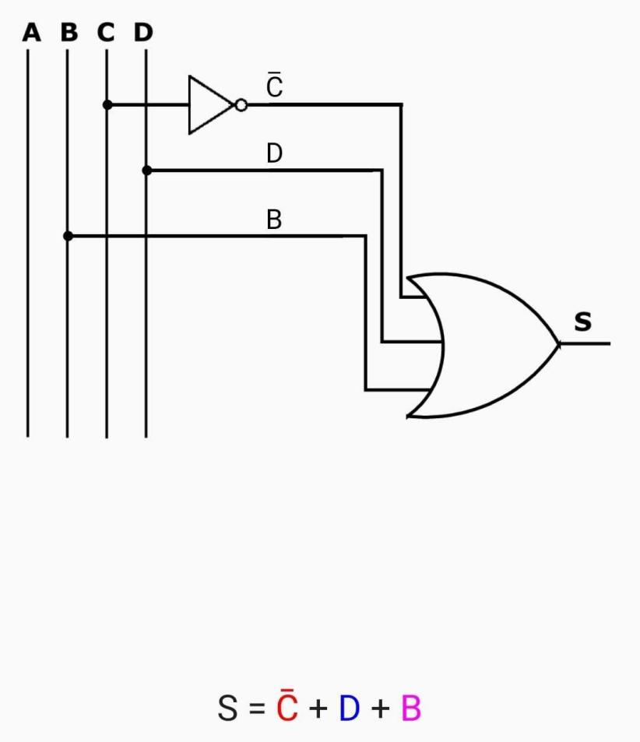

FUNCTION OF F(d):  
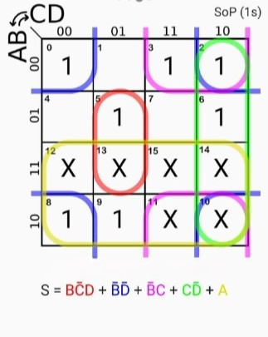 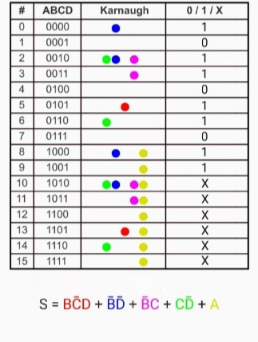

CIRCUIT:

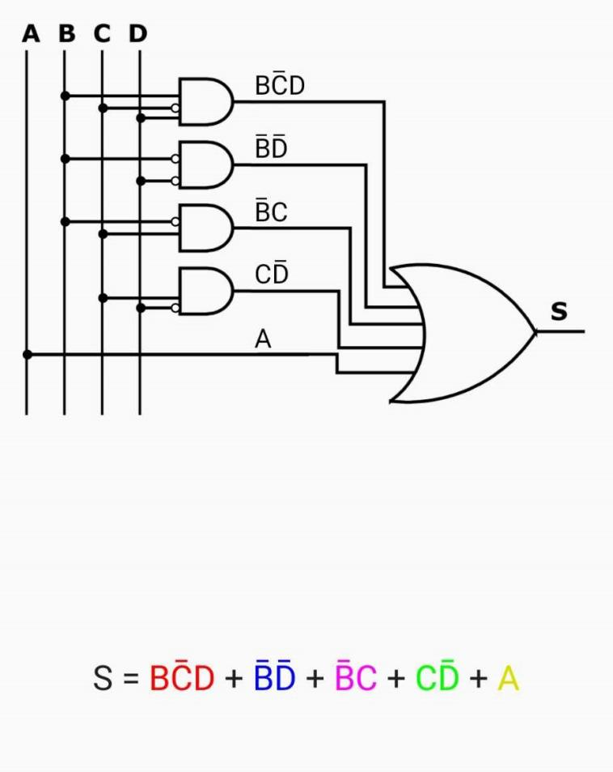

FUNCTION OF F(e):

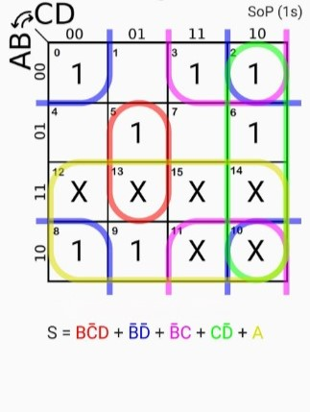 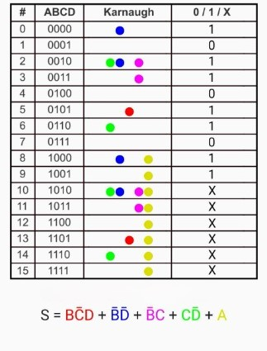

CIRCUIT:



FUNCTION OF F(f):

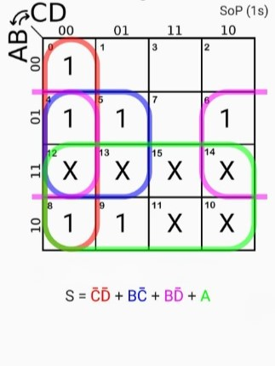 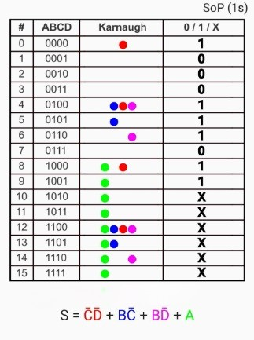

CIRCUIT:

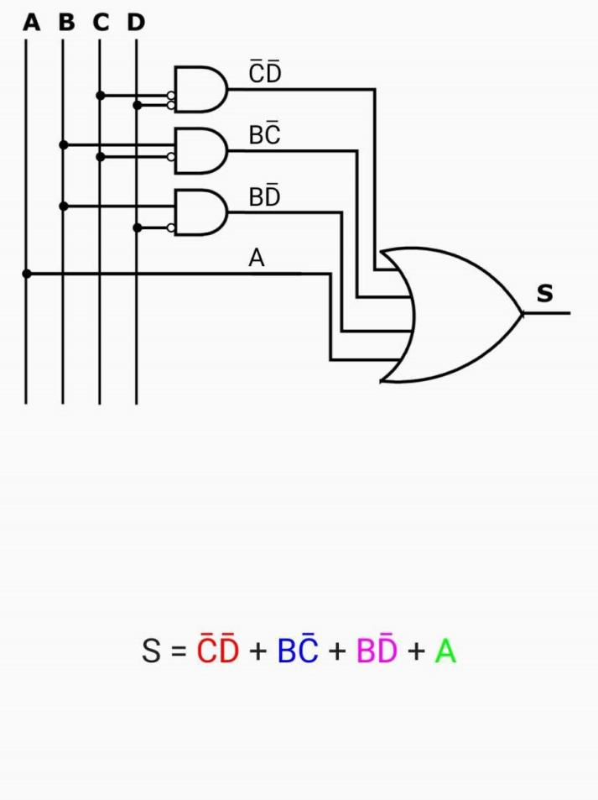

FUNCTION OF F(g):

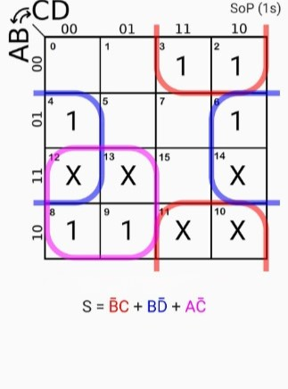 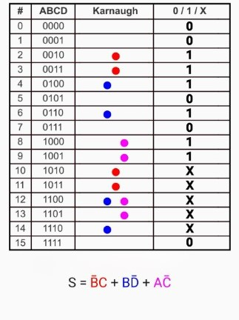

CIRCUIT:

